PARTICIPANT RESOURCES
Sample social media posts and photos have been included below for participants to use on their social networks. Sharing one of the posts below is a great way to let your friends know what you’re up to and ask them to support your fundraising efforts.
HOW TO USE A SAMPLE POST…
-Right click on an image below - “Save as”
-Upload the photo into Facebook, Twitter etc.
-Copy and paste the text from one of the samples below and post!
SOCIAL MEDIA POST #1: There are 342 kids in Waterloo Region waiting for a Big Brothers Big Sisters Mentor. Pledge me in the Bowl for Kids Sake event and help me fundraise for local youth in need. http://bit.ly/2BzFTkQ 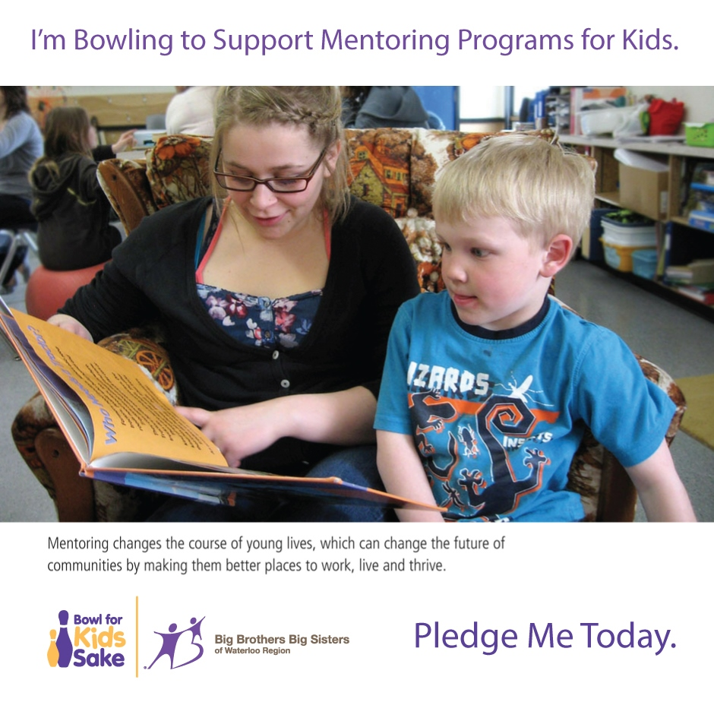

SOCIAL MEDIA POST #2: Let’s get the ball rolling for youth in need. Help me reach my Bowl for Kids Sake fundraising goal today. http://bit.ly/2BzFTkQ
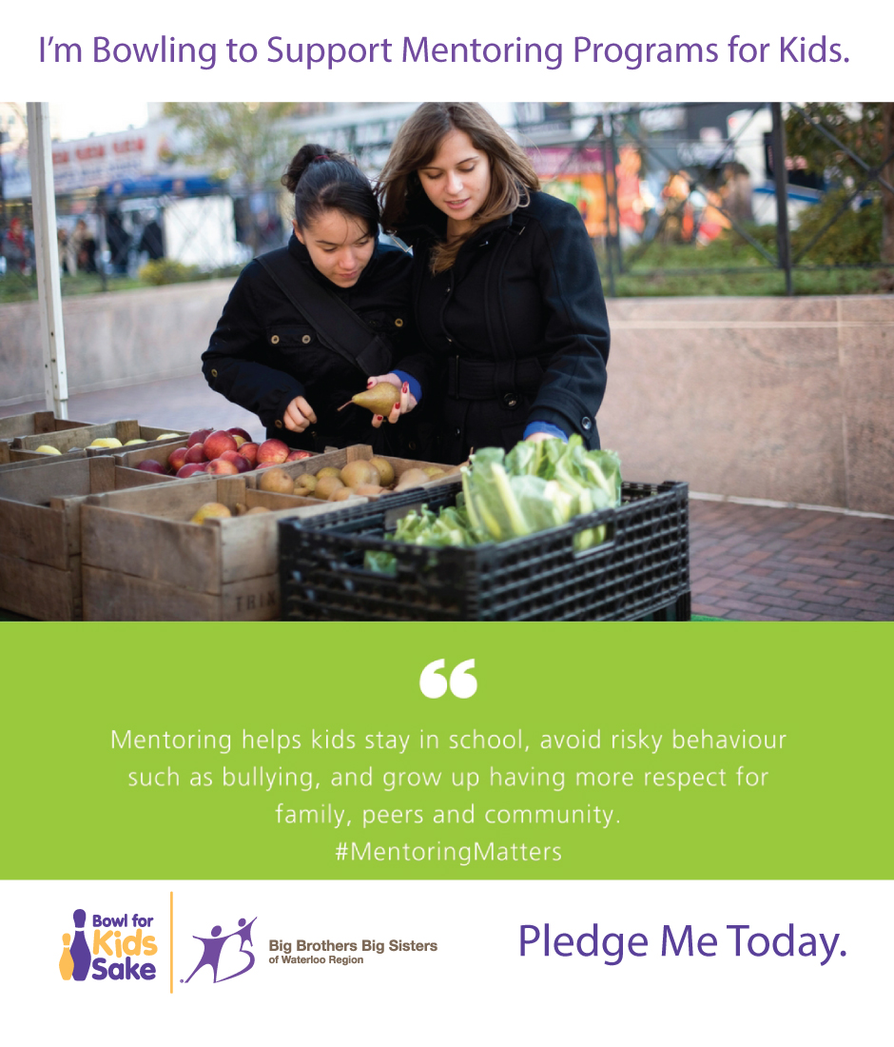

SOCIAL MEDIA POST #3: Mentoring kids could start some something big! Pledge me in the Bowl for Kids Sake event and support youth in need. http://bit.ly/2BzFTkQ
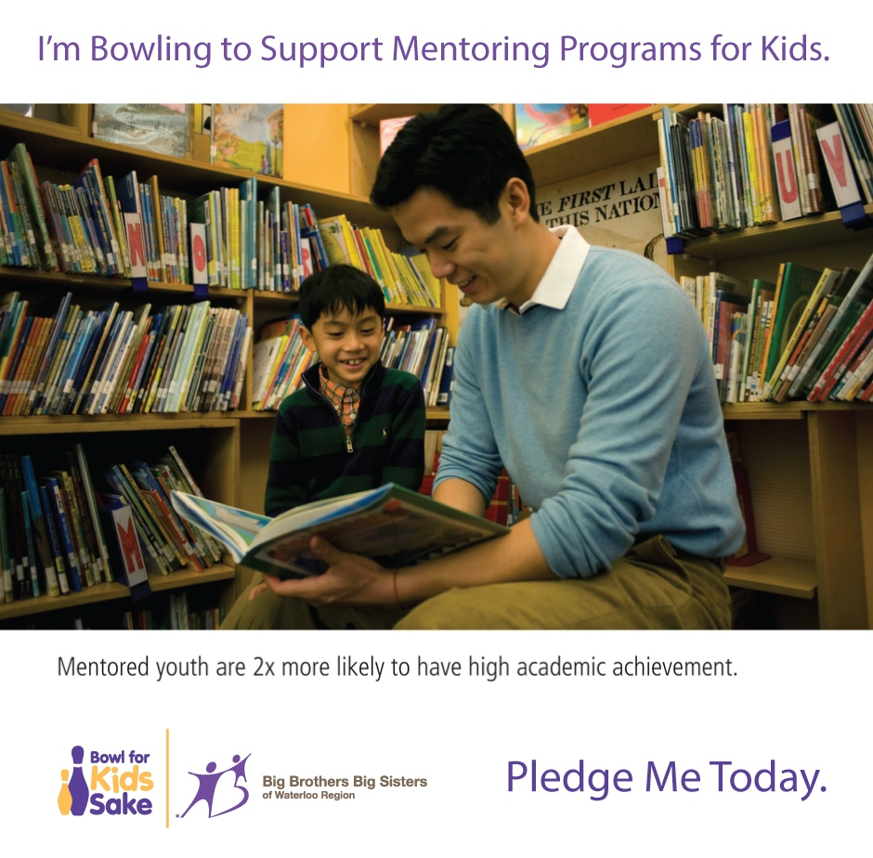

SOCIAL MEDIA POST #4: 342 local kids at Big Brothers Big Sisters are waiting for a Mentor. Pledge me today and help support youth in need. http://bit.ly/2BzFTkQ
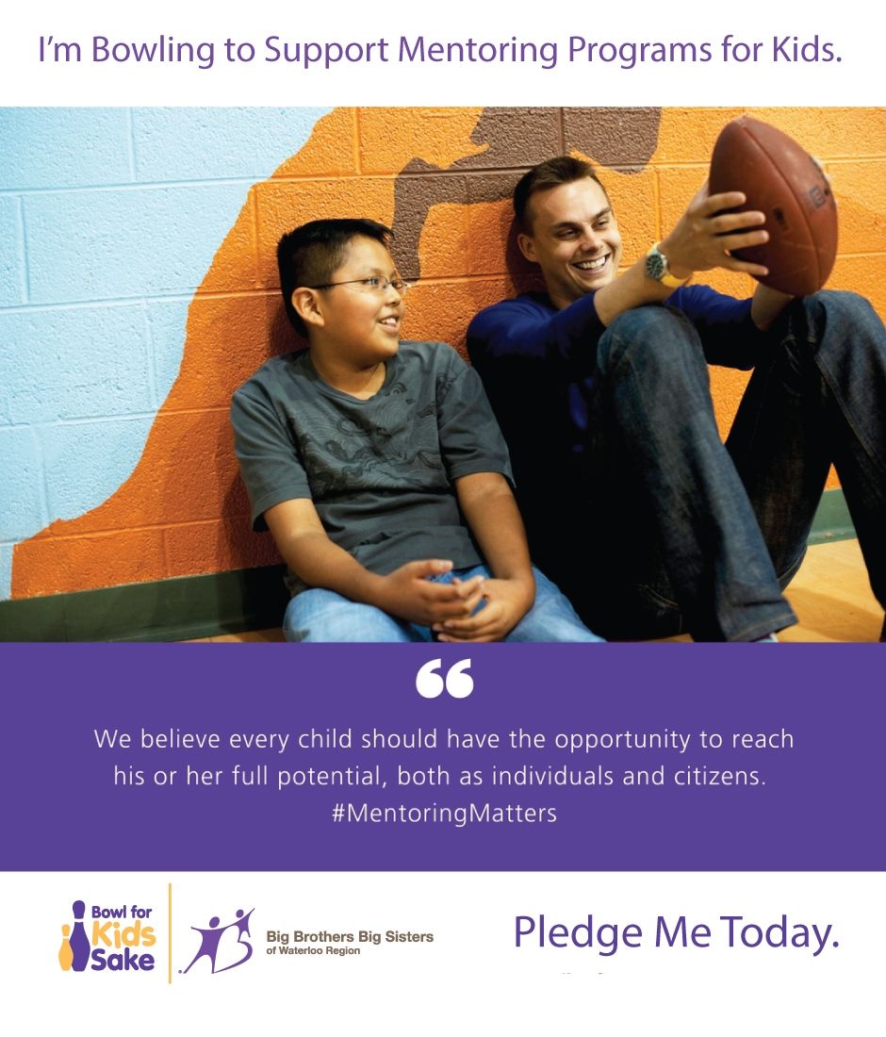

SOCIAL MEDIA POST #5: Help me reach my Bowl for Kids Sake fundraising goal and make a pledge that supports local youth. Pledge me today: http://bit.ly/2BzFTkQ
